NAME : VASUDHA TAPRIYA

REGN NUMBER: 18BCE0870

[**Corpus of Contemporary American English**](https://www.english-corpora.org/coca/x1.asp):

MODI

REASON FOR HAVING MAXIMUM NO. OF SEARCHES IN 2010-2014:

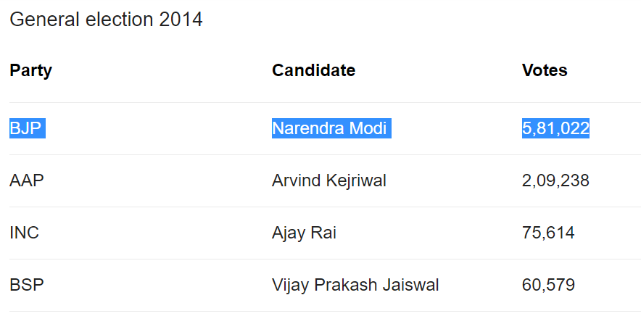

This is because Narendra Modi won the maximum no. of votes during this time and became the prime minister of India after this.